Practical No 9
File Handling in Python
File handling allows a Python program to create, read, write, and modify files stored on a computer. Python provides the built-in open() function for working with files.
Common File Modes
Mode | Purpose
r | Opens a file for reading
w | Opens a file for writing; creates a new file or overwrites existing content
a | Opens a file for appending data at the end
r+ | Opens a file for both reading and writing

Aim A: Write a Python program to read and display the contents of a file.
Code
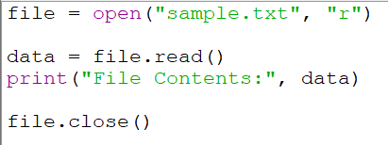
Output:
If sample.txt contains:


The output will be:

Using with open()
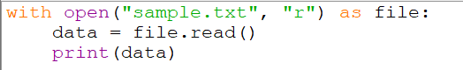
Output:
The with statement automatically closes the file.
Aim B: Write a Python program to write data into a file.
Code
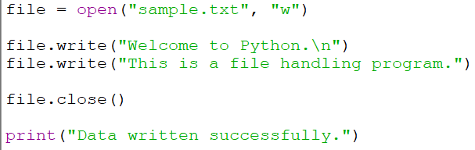
Output:
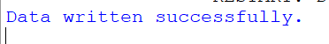
The contents of sample.txt will be:
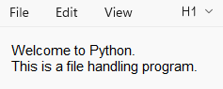

Using with open()
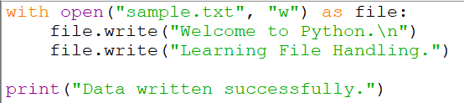


Note: Opening a file in w mode removes the existing contents of the file and writes the new data.
c. File Handling Program: Appending Data
Aim: Write a Python program to append data to an existing file.
Code
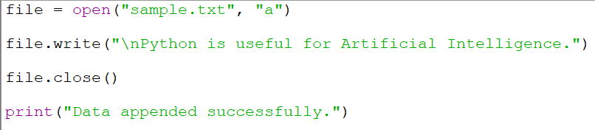
Output:
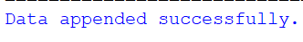
If the file originally contains:
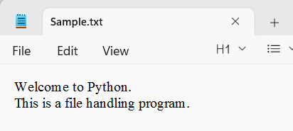
After appending, it will contain:
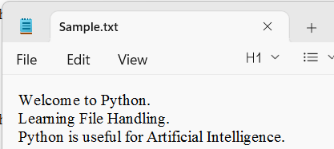
Using with open()
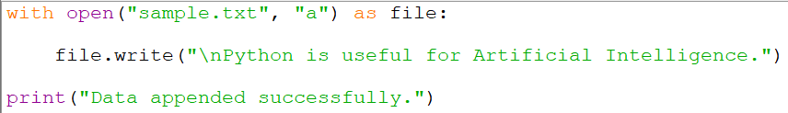
Output:

If the file originally contains:
After appending, it will contain:

